River City Science Academy Mandarin

10911 Old St. Augustine Rd. Jacksonville, FL 32257

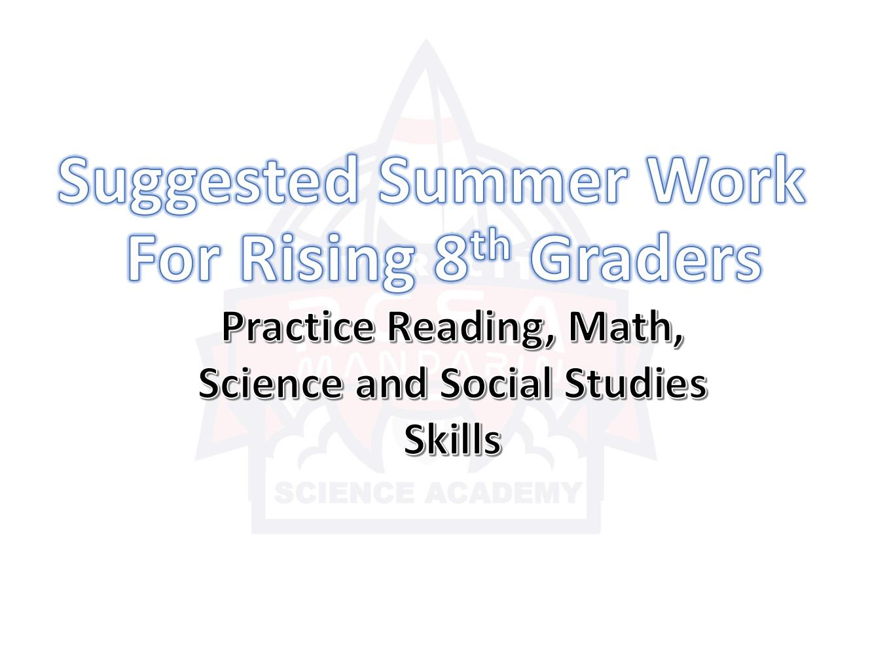

*The following reading/math assignments are targeted to help you get ready for next year by keeping up with your skills. You may complete some or all the following during your break*

10911 Old St. Augustine Rd. Jacksonville, FL 32257 Tel: (904) 855-8010 Email: mandarin-info@rivercityscience.org

Summer Reading List
REQUIRED READING FOR ALL 8TH GRADE STUDENTS:
City of Ember by Jeanne DuPrau
There will be graded assignments that goes along with the required reading for summer.

IXL Recommendations for English Language Arts Grade 8

Reading Strategies:
- F.1 Analyze Short Stories
- C.1 Identify Author’s Purpose
- B.2 Determine The Theme of Short Stories Writing Strategies:
- K.1 Identify Thesis Statements
- K. New! Identify Counterclaims Vocabulary:
- W.1 Find Words Using Context
- T.2 Positive and Negative Connotation Grammar and Mechanics:
- HH.1 Identify Adjectives
- RR.1 Formatting Titles
- QQ.1 Correct Capitalization Errors

IXL Recommendations for Math 3-Pre-Algebra

- A.1 Factors
- A.5 Greatest Common Factor
- A.6 Least Common Multiple
- B.1 Integers on a Number Line
- C.1 Integer addition and subtraction rules
- D.1 Write Fractions in Lowest Terms
- F.1 Understanding Exponents
- G.1 Convert Between Standard and Scientific Notation
- G.1 Convert Between Standard and Scientific Notation
- H.1 Understanding Ratios
*Be sure to click on “Learn with an Example” first. If you have completed this lesson, continue working toward mastery of 80% or greater.

IXL Recommendations for Algebra

- G.1 Coordinate Plane Review
- J.3 Solve One-Step Linear Equations
- J.4 Solve Two-Step Linear Equations
- P.2 Arithmetic Sequences
- P.3 Geometric Sequences
- S.3 Find the Slope of a Graph
- S.4 Find the Slope from Two Points
- S.8 Slope-Intercept Form: Write an Equation from A Graph
- BB.1 Characteristics of Quadratic Functions: Graphs
- BB.2 Characteristics of Quadratic Functions: Equations

IXL Recommendations for Geometry

- B.6 Perpendicular Bisector Theorem
- C.2 Angle Measures
- E.1 Coordinate Plane Review
- F.2 Triangle Angle-Sum Theorem
- F.3 Exterior Angle Theorem
- M.2 Triangles and Bisectors
- M.4 Angle-Side Relationships in Triangles
- R.1 Trigonometric Ratios: Sin, Cos, and Tan
- S.10 Area and Perimeter of Similar Figures
- T.5 Volume of Prisms and Cylinders
- T.6 Volume of Pyramids and Cones
- T.7 Volume of Spheres

