Summer Packet
2022-2023 School Year
7th Grade

We are so excited to welcome you to 7th grade! You'll be learning so much and can build on all you've learned last year as well. See each core (Reading/ELA, Science, Social Studies, Math) class assignments to keep your mind fresh and sharp during the summer!

*Turn this into your homeroom teacher on the first week of school and he/she will distribute to the respective core teachers for extra credit!

Reading/ELA:
Based on your REQUIRED summer reading novel, Tuck Everlasting, choose one of the following activities:

- Draw/Create an illustrated map of the main settings in Tuck Everlasting. Label the places that play an important role in the story.
- Imagine that you could choose to stay the same age forever. What age would you choose? List three reasons why you would want to be that age. Then list three problems with staying that age forever.
- Imagine that the Tucks are everlasting and still wandering earth. Write a description of them if they came into your town this year. Describe where you might seem them, what they would be doing, and how you would recognize them
* Be creative! Show us how much you enjoyed the story *
*Note: There will be an assessment on Tuck Everlasting in addition to this summer activity. There are multiple places to find the book online for free.*

Civics/Law Studies:
In your social studies classes this year, you will be learning a lot about media, its influence on the public and in turn, its influence on our government. So, interpreting media messages is a great skill to learn and practice. One of the ways we will do this throughout the year is by studying political cartoons. See the next two pages for a deeper description of political cartoons and the “POPES” strategy for analyzing them.
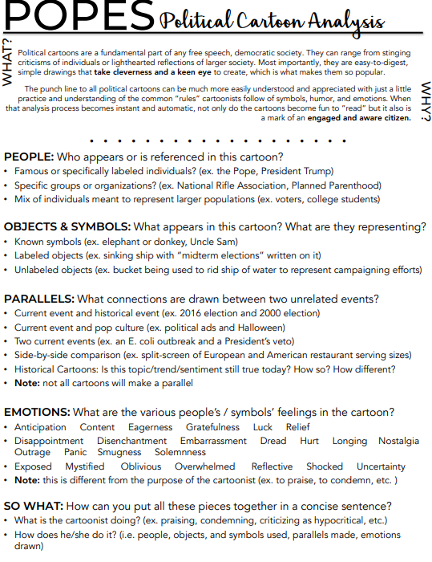 Now you try !
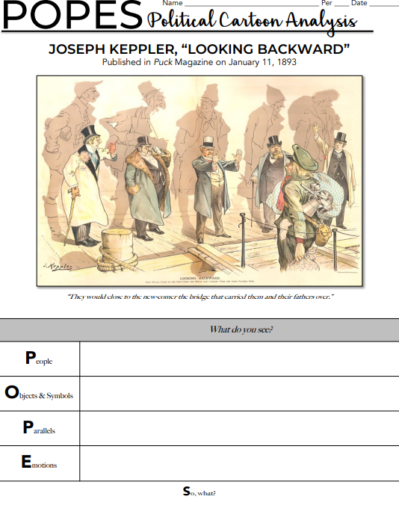
Science: Famous thinkers
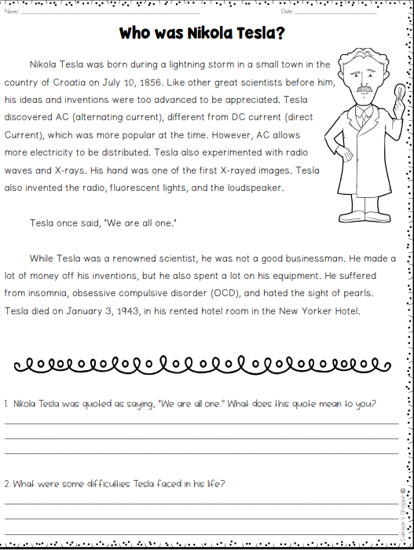
For extra summer fun follow this link for a ‘sweet’activity :
https://docs.google.com/presentation/d/1iGvXqKg-2Uv12iw60zh2STPFiEoG6a3CpjFC-P0g4sk/copy?usp=sharing
Math : Work it Out!
