Summer Packet
2022-2023 School Year
6th Grade

Dear Incoming 6th Grade Students:
We are looking forward to our upcoming year together. We have prepared some activities for you to work on over the summer to keep your mind active for the next school year. Please see the attached activities prepared by your new teachers. Have a great summer!

- RCSA Mandarin 6th Grade Team

*Turn this into your homeroom teacher on the first week of school and he/she will distribute assignments to the respective core teachers for extra credit!
Reading/ELA:
6th grade REQUIRED Summer Reading novel
- Holes, by Louis Sachar
*Note: There will be an assessment on Holes within the first 2 weeks of school, in addition to this summer activity.

CLICK HERE to access the pdf version of Holes.
CLICK HERE to purchase via Amazon.

- Based on your required summer reading, choose one of the following activities:
    - Draw/Create an illustrated map of the main settings in Holes. Label the places that play an important role in the story.
    - Write a one page about why you believe the boys resort to using nicknames. What do these nicknames say about the “campers?”
    - Use a Venn diagram to compare and contrast the book and the movie.

Math:
Instructions:
- Read each section of the packet carefully and answer every question.
- Please ensure that your name is written on the packet and once you show up to class, you will write the appropriate class period on the front under your name.
- Make sure to show your work.

Math - Summer Packet

Name ________________________ Class Period __________

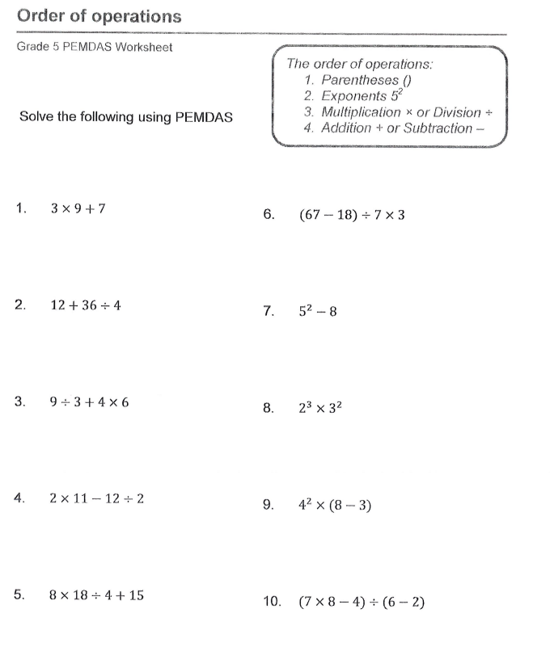
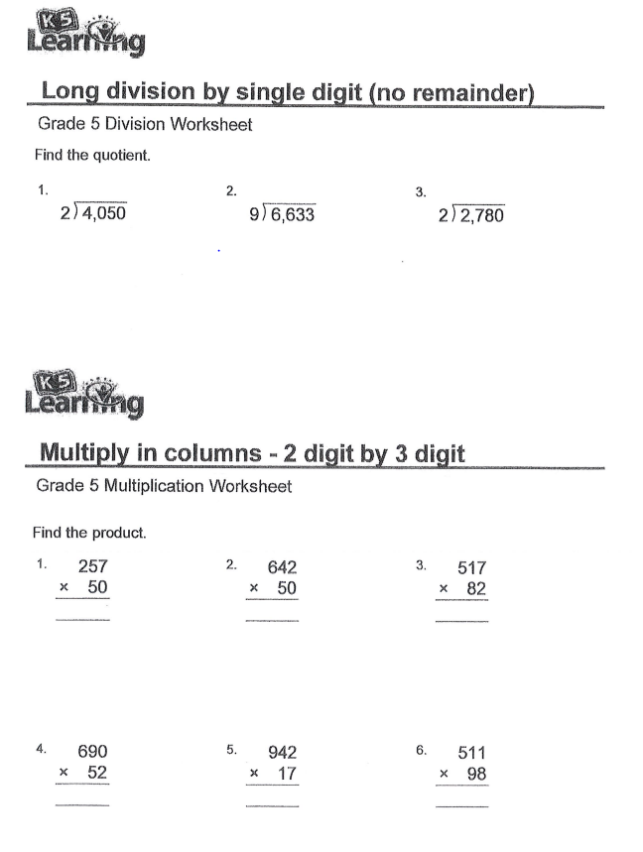
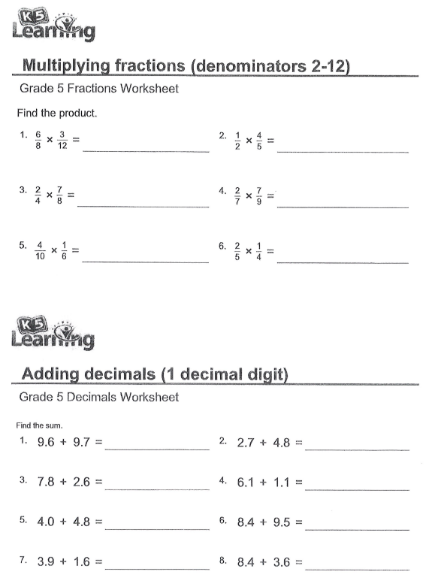
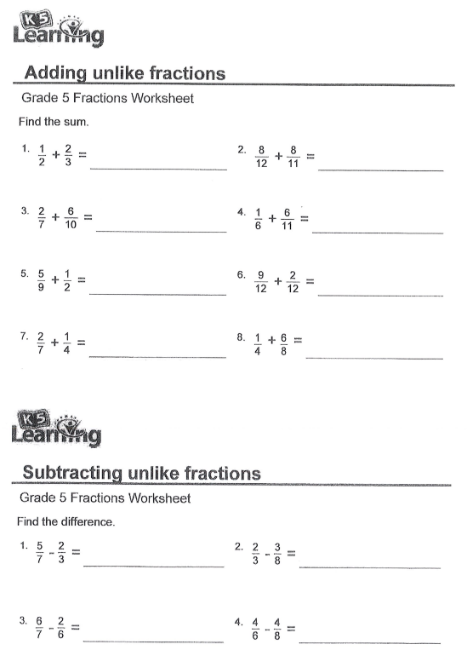

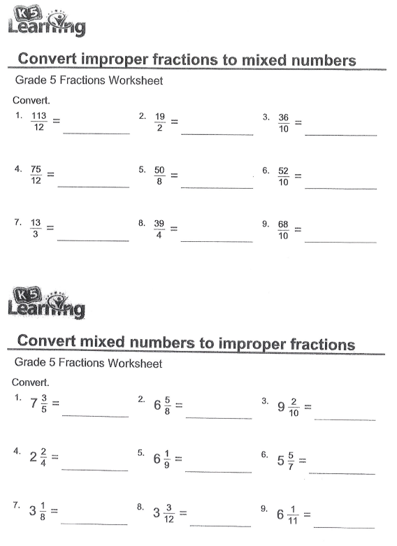

World History:
- There are two parts to the World History Summer Assignment.
    - Part 1 is the map of the world where you will locate the countries, bodies of water, and areas of importance.
    - Part 2 is an essay, of your choosing, from a list of topics.
    - Each part of the assignment is outlined below.

Part 1- The Map
Directions: For this section, you have been provided with a blank map of the world. You may use the internet, books, or other resources to find the countries, continents, and bodies of water that are listed below.
- You should fill out this map in its entirety. Make sure to create a key, if needed.
- Above all, label your map neatly.

Continents:
- Label all but Antarctica (which isn’t pictured)

Oceans/Bodies of Water:
- Aegean Sea
- Arctic Ocean
- Atlantic Ocean
- Baltic Sea
- Bay of Bengal
- Black Sea
- Caspian Sea
- Great Lakes
- Gulf of Mexico
- Indian Ocean
- Lake Victoria
- Mediterranean Sea
- Pacific Ocean
- Persian Gulf
- Red Sea
- South China Seas
- Tigris and Euphrates Rivers
- Yellow Sea/East China Sea

Countries:

- Afghanistan
- Argentina
- Australia
- Brazil
- Canada
- Chile
- China
- Egypt
- England
- Ethiopia
- France
- Germany
- Greece
- India
- Iran
- Iraq
- Ireland
- Israel
- Italy
- Japan
- Mexico
- Mongolia
- North Korea
- Norway
- Pakistan
- Peru
- Poland
- Portugal
- Russia
- Saudi Arabia
- South Africa
- South Korea
- Spain
- Syria
- Taiwan
- Turkey
- Ukraine
- United States of America

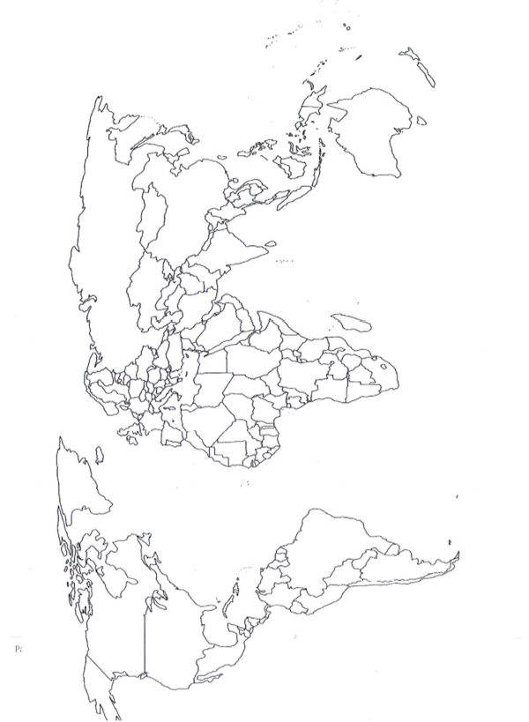

Part 2- The Essay
Below is a list of topics that we will learn about in World History. Choose a topic to research using Ducksters.com, History.com, or another educational website and write a 3-5 paragraph essay discussing how the culture evolved and changed during ancient times.
- Discuss the way people lived, what they ate, their religion, and any other important information you find about the topic.
- Become an expert, so you can share what you know as we learn about each topic.

Topics:
- Early Humans
- Mesopotamia
- Egypt
- India
- China
- Hebrews and Judaism
- Greece
- Rome
- Islam
- Africa
- Japan
- Aztecs

Science:
- The following assignment is designed to give you an insight as to how we will be using our scientific skills to analyze information and make conclusions based on pure scientific evidence.

Instructions:
- Read each section of the packet carefully and answer every question.
- Please ensure that your name is written on the packet and once you show up to class, you will write the appropriate class period on the front under your name.
- The pages of the Science packet should be stapled neatly and placed in a folder. You will be expected to have this completed and turned in on the first day of school.

Science - Summer Packet

Name ________________________ Class Period __________

